

MARMARA UNIVERSITY
FACULTY OF ENGINEERING
PHYS 1103.4
PHYSICS LABORATORY

EXPERIMENT 5

FINDING STATIC FRICTION COEFFICIENT
Section Number: 7
Group Number: 8
Submitted to: Arş. Göv. Hüseyin YALTIRIK
Due Date: 21.12.2021

 | Dept | Student Id | Name Surname | Contribution
1 | EE | 150720062 | MEHMET ALİ KAMALAK | Calculation, word layout
2 | EE | 150720017 | MUSTAFA BAŞBOĞA | Purpose, theory, conclusion

CONTENTS

PURPOSE: 3
THEORY: 3
CALCULATION: 4
For Experiment: 4
Table 1: values of measurement 4
Table 2:connection of coefficient and mass 4
CONCLUSION: 5
COMMENT: 5
REFERENCES: 5

PURPOSE:
In this experiment, we observed the motion of a cube in the inclined plane using four surfaces made of different materials, and then we continued our observations by adding weight to the cube and examining the effects of weight.

THEORY:
The sum of all the forces acting on a body is called as the net force. If there is a net force on an object, it is accelerated in the direction of this force. The forces acting on the mass in the inclined plane are shown below based on these forces we get a net force. The statical friction coefficient (µ) between the surface of the mass and the surface of the plane will be determined experimentally. Since we used different positions and different surfaces in this experiment, we averaged the resulting angles.
( W= mg ) ( Fx= mgsinθ ) ( Fy= mgcosθ )

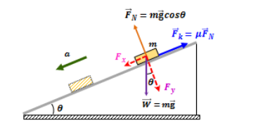

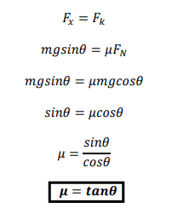

CALCULATION:

For Experiment:

Table 1: values of measurement

Table 2:connection of coefficient and mass

CONCLUSION:
In this experiment, we learned a lot of new information, perhaps the most important of which is the ineffectiveness of mass. Before we make observations and create data, the mass will have a great effect and cause positive deviations in the data.
We thought it would happen, but the effect of the mass misled us. But the surface difference and the resulting different friction coefficients turned out to be as we expected, just like the cube in different positions on the inclined plane and moving from different positions.
Since even a small mistake we made during the experiment would change all the data we received, we worked very carefully and tried to get correct data. We enjoyed our experience very much and we look forward to new experiments.

COMMENT:
We repeated this experiment at different masses, at different starting points, and on different surfaces. We recorded the data we obtained. We thought that the friction constant we found by calculating these data would be different, but it turned out to be almost equal to each other. From this experiment, we understand that the change in mass, surface and starting points does not change the coefficient of friction.

REFERENCES:
Edmodo experiment 5 pdf

